Spring Boot REST API with CRUD Operations — Product Management
Course: DBSE and DBD Project: DBMSPractice (artifact DBMSPractice_WEEK8)
Stack: Java 17 · Spring Boot 4.1.1 · Spring Web MVC · Spring Data JPA (Hibernate) · MySQL 8.0 · Maven · Postman

1. Aim
Build a Spring Boot web application that manages a list of products in a warehouse. The application exposes a REST API supporting Create, Read, Update and Delete (CRUD) operations on product details (ID, Name, Description, Price, Quantity). Spring Web MVC handles HTTP requests, Spring Data JPA handles persistence, and data is stored in a MySQL database. Dependency injection is used to wire the controller, service and repository layers.

2. Architecture
Postman / HTTP client
│ JSON over HTTP (port 8989)
▼
ProductController (@RestController, /api/products) ← web layer
│ calls
▼
ProductService ◄── ProductServiceImpl (@Service) ← business layer
│ calls
▼
ProductRepository (extends JpaRepository<Product, Long>) ← data-access layer
│ Hibernate / JDBC
▼
MySQL schema "kluh", table "products"

Project structure
DBMSPractice
├── pom.xml
├── src/main/java/com/klu
│ ├── DbmsPracticeApplication.java (@SpringBootApplication entry point)
│ ├── controller/ProductController.java
│ ├── entity/Product.java
│ ├── repository/ProductRepository.java
│ └── service/ProductService.java, ProductServiceImpl.java
├── src/main/resources/application.properties
├── src/test/java/com/klu/DbmsPracticeApplicationTests.java
└── docs/ (this documentation + screenshots)

Dependency injection
Both injections in this project are constructor-based (Spring injects the single constructor automatically):
Class | Injected dependency
ProductController | ProductService
ProductServiceImpl | ProductRepository

(The lab sheet labels the controller's injection "setter-based" in a comment, but its code is constructor injection. A setter-based variant would use a @Autowired setter method instead.)

3. Setup

3.1 Prerequisites
- JDK 17+, Spring Tools for Eclipse (STS) or any IDE, Postman
- MySQL Server 8.0 (service MySQL80) and MySQL Workbench / CLI

3.2 Maven dependencies (pom.xml)
- spring-boot-starter-webmvc — Spring Web MVC / REST
- spring-boot-starter-data-jpa — Spring Data JPA + Hibernate
- mysql-connector-j — MySQL JDBC driver
- spring-boot-devtools — developer convenience (optional)
- test starters for JPA and Web MVC

3.3 Database
Create the schema once (the products table itself is generated by Hibernate):
CREATE DATABASE IF NOT EXISTS kluh;

3.4 application.properties
spring.application.name=DBMSPractice
spring.datasource.url=jdbc:mysql://localhost:3306/kluh
spring.datasource.username=root
spring.datasource.password=root
spring.jpa.database-platform=org.hibernate.dialect.MySQLDialect
spring.jpa.hibernate.ddl-auto=update
spring.jpa.show-sql=true
server.port=8989

ddl-auto=update makes Hibernate create/alter the products table from the entity. show-sql=true prints every SQL statement to the console.

4. Implementation summary
File | Role
Product | JPA entity mapped to table products: id (@Id, @GeneratedValue(IDENTITY)), name, description, price (double), quantity (int)
ProductRepository | JpaRepository<Product, Long> — supplies findAll, findById, save, deleteById with no implementation code
ProductService / ProductServiceImpl | Business logic: list, get (throws RuntimeException("Product not found") if missing), save, update (load → copy fields → save), delete
ProductController | REST endpoints, returns ResponseEntity with proper status codes

The full source is in src/main/java/com/klu/... and matches the lab sheet.

5. API endpoints
Base URL: http://localhost:8989/api/products
HTTP method | Endpoint | Description | Success response
GET | /api/products | Get all products | 200 + JSON array
GET | /api/products/{id} | Get product by ID | 200 + JSON object
POST | /api/products | Create new product | 200 + created product (with generated id)
PUT | /api/products/{id} | Update existing product | 200 + updated product
DELETE | /api/products/{id} | Delete a product | 204 No Content

The lab sheet's endpoint table lists the "Create new product" row under GET; the correct method (and what the code implements) is POST.
Request body for POST / PUT:
{ "name": "Laptop", "description": "Dell Inspiron 15", "price": 55000.50, "quantity": 10 }

6. How to run
From the IDE: right-click the project → Run As → Spring Boot App (or open the Boot Dashboard and start DBMSPractice).
From the command line (project root):
./mvnw clean package
java -jar target/DBMSPractice_WEEK8-0.0.1-SNAPSHOT.jar

Console shows Tomcat started on port 8989 and Started DbmsPracticeApplication.

7. Testing

7.1 Automated test
DbmsPracticeApplicationTests.contextLoads — 1 test, 0 failures (confirms the Spring context, JPA and MySQL connection start correctly).

7.2 Postman
GET all products — GET http://localhost:8989/api/products → 200 OK
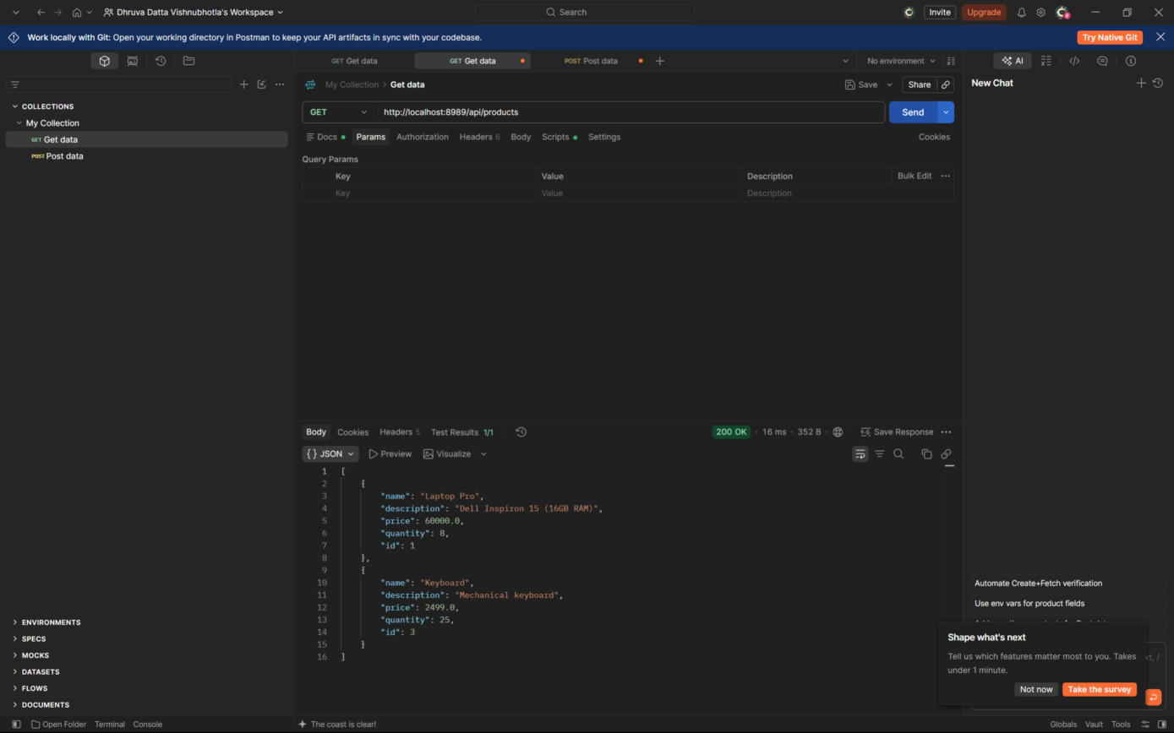
POST create product — POST http://localhost:8989/api/products, Body → raw → JSON → 200 OK, id generated as 3
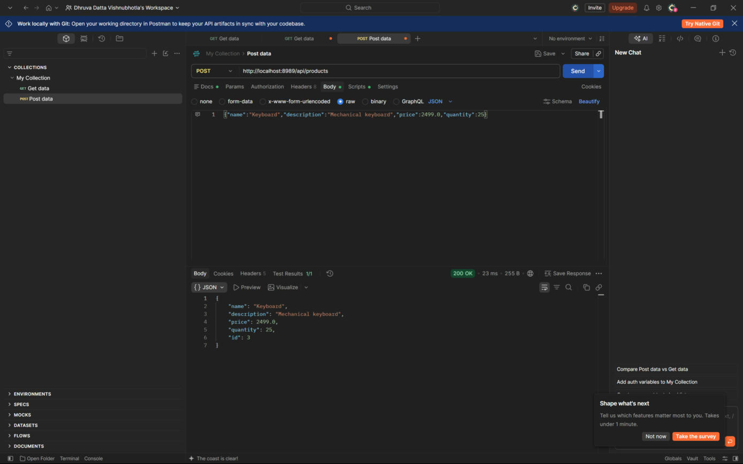

7.3 Full CRUD run (command-line, curl)
# | Request | Result
1 | POST Laptop (55000.50, qty 10) | 200 — {"name":"Laptop",…,"id":1}
2 | POST Wireless Mouse (799.0, qty 50) | 200 — {…,"id":2}
3 | GET /api/products | 200 — array with both products
4 | GET /api/products/1 | 200 — Laptop
5 | PUT /api/products/1 → "Laptop Pro", 60000.0, qty 8 | 200 — updated product
6 | GET /api/products/1 | 200 — shows updated values (persisted)
7 | DELETE /api/products/2 | 204 No Content
8 | GET /api/products | 200 — only product 1 remains
9 | GET /api/products/99 (nonexistent) | 500 — see note below

Raw output of this run is saved in target/run/curl-results.txt (regenerated on each run; target/ is not source-controlled).

7.4 Database verification
After the tests above and the Postman POST/GET:
mysql> DESCRIBE products;
+-------------+--------------+------+-----+---------+----------------+
| Field | Type | Null | Key | Default | Extra |
+-------------+--------------+------+-----+---------+----------------+
| id | bigint | NO | PRI | NULL | auto_increment |
| description | varchar(255) | YES | | NULL | |
| name | varchar(255) | YES | | NULL | |
| price | double | NO | | NULL | |
| quantity | int | NO | | NULL | |
+-------------+--------------+------+-----+---------+----------------+

mysql> SELECT * FROM products;
+----+-----------------------------+------------+-------+----------+
| id | description | name | price | quantity |
+----+-----------------------------+------------+-------+----------+
| 1 | Dell Inspiron 15 (16GB RAM) | Laptop Pro | 60000 | 8 |
| 3 | Mechanical keyboard | Keyboard | 2499 | 25 |
+----+-----------------------------+------------+-------+----------+

Row 2 was deleted via the API; the id gap is expected with AUTO_INCREMENT. The Hibernate SQL log shows the statements the API produced (insert into products …, select … from products, delete from products where id=?).

8. Issues found and fixed during completion
# | Problem | Fix
1 | DbmsPracticeApplication.java contained a stray 0 after SpringApplication.run(...); — compile error | Removed it
2 | Main class was in com.example.demo while all other classes are in com.klu. Spring Boot only scans the main class's package and sub-packages, so no controller/entity/repository was registered: every request returned 404 and no products table was created | Moved DbmsPracticeApplication (and its test) to package com.klu
3 | Service implementation file/class was misspelled ProductServideImpl | Renamed to ProductServiceImpl as in the lab sheet
4 | Database kluh referenced by application.properties did not exist (Hibernate creates tables, not schemas) | Ran CREATE DATABASE kluh;
5 | Postman requests pointed to https://localhost:8839/... and postman-echo.com/post | Changed both to http://localhost:8989/api/products (note: http, port 8989)

Known limitation
Requesting or updating a non-existent id throws a plain RuntimeException("Product not found"), which Spring returns as HTTP 500. This matches the lab sheet code. A cleaner design would throw a custom ProductNotFoundException mapped to 404 via @ResponseStatus or a @RestControllerAdvice.

9. Viva questions and answers
1. Role of each layer (Controller, Service, Repository) in CRUD?
The Controller handles HTTP requests/responses and maps them to service methods. The Service holds business logic and coordinates the repository. The Repository talks to the database through Spring Data JPA, giving CRUD methods such as save(), findById(), findAll() and deleteById().
2. How to connect Spring Boot to a relational database; which dependencies?
Add spring-boot-starter-data-jpa and the MySQL/PostgreSQL driver to pom.xml. In application.properties set the datasource URL, username, password, dialect, and spring.jpa.hibernate.ddl-auto=update for automatic schema management.
3. How to create and map a JPA entity?
Annotate the class with @Entity and @Table; map the key with @Id and @GeneratedValue; optionally customise columns with @Column. Extending JpaRepository<Entity, ID> then provides CRUD operations for that table.
4. How to validate data before saving?
Use the Bean Validation API (jakarta.validation in Spring Boot 3+/4, formerly javax.validation) with the spring-boot-starter-validation dependency. Annotations such as @NotBlank, @Size, @Min, @Max, @Positive define constraints; @Valid on the controller's @RequestBody parameter enforces them before processing.
5. Purpose of `@Transactional`?
It runs multiple database operations as one unit of work: if any operation fails, all changes are rolled back, keeping data consistent. (Spring Data's save/deleteById are already transactional individually; use @Transactional on service methods that perform several operations.)

